Sri Lanka Institute of Information

Technology



Lab Submission

Lab Sheet 09

**IT24103921**

**Samarawickrama N. A. N. D**

**Probability and Statistics | IT2120**

B.Sc. (Hons) in Information Technology

**Exercise :**

1. Assume that the time taken to bake a batch of cookies is normally distributed with mean 45 minutes and standard deviation 2 minutes.
2. Generate a random sample of size 25 for the baking time.

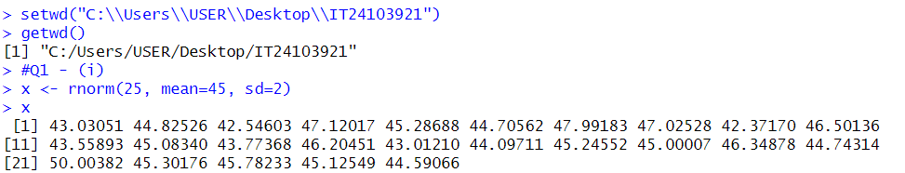

1. Test whether the average baking time is less than 46 minutes at a 5% level of significance.

